KOK Kitchens — Equipment Hire: Inventory & Booking Design
Prepared by: Ophir Digital For: KOK Kitchens Date: 19 June 2026 Status: Built — MVP live (availability + soft‑hold bookings). Deposits deferred. See §9.

1. Purpose
This document captures the proposed design for turning the KOK Kitchens equipment‑hire section from a simple enquiry form into a live, inventory‑backed booking system — one that knows how much stock exists, shows customers what is actually available for their event date, reduces availability automatically as bookings come in, and tracks items back through return and restocking.
It records the two workflow diagrams (customer‑facing and behind‑the‑scenes), the data model, the return/restock mechanism, the notification decision, and the build plan.

2. The customer journey
This is the flow a customer experiences. It is suitable to embed on the /hire page as a simple “how hire works” section.
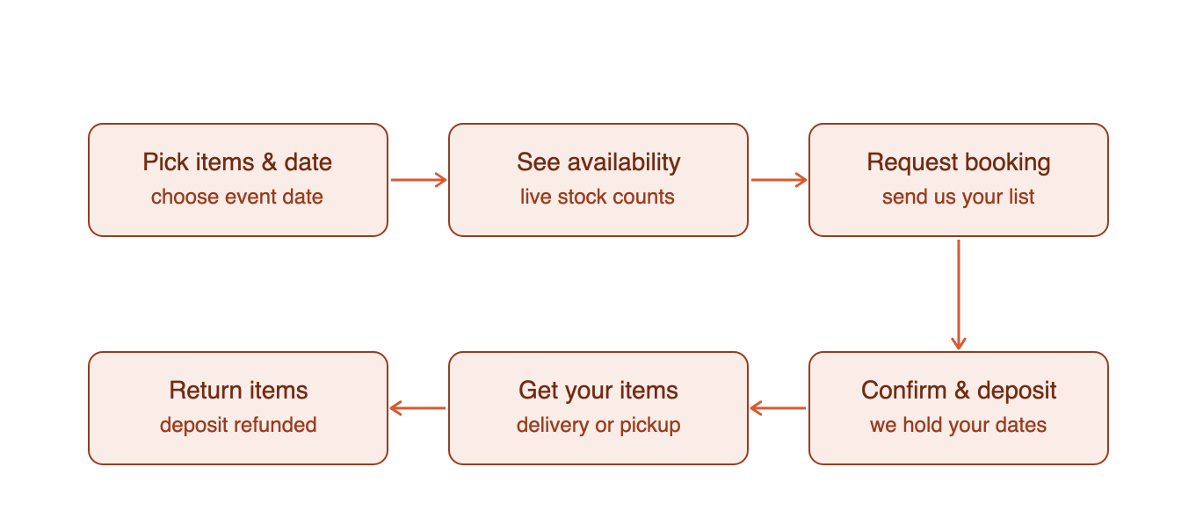
Customer hire journey
The journey deliberately starts with the event date. Hire availability only makes sense against a date, so the date is collected before any stock is shown.
Step | What the customer does | What happens behind the scenes
Pick items & date | Chooses items and an event date | —
See availability | Sees live “in stock / limited / fully booked” | Availability calculated for that date
Request booking | Submits their list | Booking saved as an enquiry / soft hold
Confirm & deposit | We confirm and request a deposit | Stock reserved against their dates
Get your items | Delivery or collection | Items marked “on hire”
Return items | Returns after the event | Deposit refunded; items restocked

3. The inventory engine
This is the behind‑the‑scenes mechanism that answers the two key questions: how is availability deduced and what is the mechanism of return and restocking.
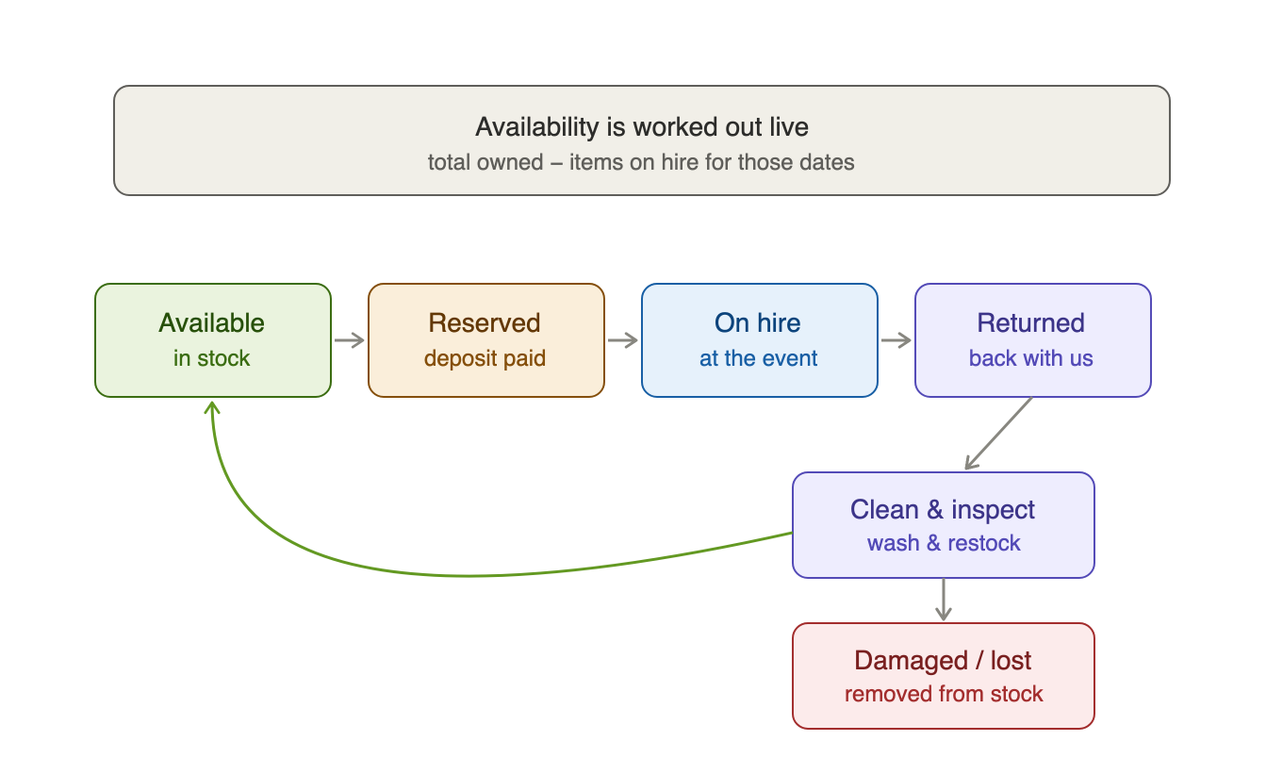
Hire inventory engine

3.1 How availability is deduced
The single most important point: hire is date‑ranged. Unlike the food menu (a simple available / unavailable toggle), a hire item is not “gone” when booked — it is only unavailable for events that overlap its hire window, then it returns to the pool.
So availability is never a single stock number; it is calculated per requested date:
shown to customer = total owned − units on hire whose dates overlap the customer's date
On the /hire page this surfaces as per‑item status — for example “6 in stock”, “only 2 left for your date”, or “fully booked — try another date” — and the quantity steppers are capped at what is actually available so customers cannot over‑book.

3.2 The return & restock lifecycle
Each unit cycles through the states shown in the diagram:
State | Meaning | Consumes availability?
Available | In stock, ready to hire | No
Reserved | Deposit paid, dates held | Yes
On hire | Out with the customer at the event | Yes
Returned | Physically back with us | Yes (until restocked)
Clean & inspect | Being washed / checked / restocked | Yes (turnaround buffer)
Damaged / lost | Written off | No — permanently reduces total owned
Two details matter:
- Turnaround buffer — an item stays unavailable for a day or two after return (washing and checking) before re‑entering the pool, so we never promise a Sunday item that is still dirty from Saturday.
- Damaged / lost is the only thing that shrinks real inventory — it permanently reduces total_qty. Everything else is a temporary hold that frees up again.
Restocking is therefore just a status change in admin (“mark returned” → “mark restocked”), which automatically returns those units to the available pool for new bookings.

4. Current state vs. what this needs
Area | Today | Needed for live inventory
Catalogue | Static price list (lib/hire-data.ts) | Same list + a stock count per item
Stock | None | hire_inventory table
Bookings | Not saved — emailed only (/api/hire-enquiry) | hire_bookings table with dates + status
Availability | Not shown | Calculated live per date
Returns | Manual / informal | Status workflow in admin
Database | Neon Postgres already in use (lib/db.ts) | Add two tables alongside orders

5. Proposed data model
Two new tables in the existing Neon Postgres database.
hire_inventory — how many of each item KOK owns.
Column | Type | Notes
item_id | TEXT (PK) | Matches an id in hire-data.ts
total_qty | INTEGER | Units owned (reduced only by write‑offs)
updated_at | TIMESTAMPTZ | —
hire_bookings — a saved booking and its lifecycle.
Column | Type | Notes
ref | TEXT | e.g. HIRE‑AB123
customer_name / phone / email | TEXT | Contact details
hire_out_date | DATE | When items go out
return_date | DATE | When items come back
items | JSONB | [{ item_id, quantity }]
status | TEXT | enquiry → confirmed → out → returned → closed (or cancelled)
deposit | NUMERIC | Optional
created_at | TIMESTAMPTZ | —
Availability for a date = total_qty − the summed quantities of bookings whose [hire_out_date, return_date + buffer] window overlaps the requested window and whose status is one that holds stock (reserved / out / returned‑not‑yet‑restocked).

6. Notifications (ntfy) — recommendation
Hire enquiries currently fire to the same ntfy topic as food orders (kok-kitchen-orders, in /api/hire-enquiry).
Recommendation: give hire its own topic — kok-kitchen-hire, via a new NTFY_HIRE_TOPIC environment variable.
- Different cadence & urgency — food orders are same‑day and time‑critical; hire is future‑dated event planning. Mixing them buries one stream in the other.
- Different handler — whoever manages logistics and stock can subscribe to hire alerts without the food‑order firehose, and mute either independently.
- Low cost — one environment variable and a one‑line code change. The only trade‑off is subscribing to two topics in the ntfy app.
This change is independent of the inventory build and can be made on its own.

7. Build plan (phased)
Phases 1–3 are built and verified in this release; phase 4 (deposits) is deferred.
- ✅ Database + availability API — hire_inventory and hire_bookings tables, a /api/hire-availability?date endpoint, and persistence of enquiries as bookings.
- ✅ Customer /hire page — an event‑date picker, live availability badges, and quantity steppers capped at available stock.
- ✅ Admin — set/clear stock counts, view bookings, and change status (confirm → out → returned → closed / cancelled).
- ⬜ Deposits (optional, not in MVP) — reuse the existing Stripe checkout infrastructure to take a deposit at booking and auto‑refund on return.

8. Decisions made
- Soft hold — a fresh enquiry places a 48‑hour soft hold so two customers aren’t both told “available” for the same date. The hold lapses automatically if not confirmed.
- Turnaround buffer — 1 day after return before an item is available again.
- Deposits — manual for now (Stripe deposit collection deferred — see §7.4).
- ntfy — split confirmed: hire alerts go to kok-kitchen-hire.

9. Going live — your checklist
The hire MVP is built and verified. To switch it on:
- Run GET /api/init once on the live site after this release deploys — it creates the two hire tables (idempotent; safe to re‑run).
- Set your stock counts in Admin → Hire stock: enter how many of each item you own and press Save. Items left blank stay “unmanaged” — shown to customers without a stock cap, exactly as the page works today. Use Clear to stop managing an item.
- Subscribe to the kok-kitchen-hire ntfy topic in your ntfy app so hire enquiries reach you separately from food orders.
Once stock is set, customers pick an event date on /hire and see live availability (“6 available”, “Only 2 left”, “Fully booked”), with quantities capped so they can’t over‑book. Each enquiry places a 48‑hour soft hold; in Admin → Hire stock you move it through confirmed → out → returned → closed (or cancelled). Mark a booking closed once items are cleaned and back in stock.
Not included in this MVP (can be added later): online deposit collection/refund via Stripe.

